Problem 1:

X

Y

c

c´

20

10

25

50

d

d´

b

b´

10

20

5

a

a´

`

30

60

Problem 2:

**SOLUTION STEPS:**

X

Y

a’

1’

a

b’1

LTV = 65

TL = 75

b1

1

b’

b

LFV = 50

TV = 65

FV = 50

Φ

TL = 75

θ

12

1.Draw XY line and one projector.

2.Locate a’ on XY and

a 12 mm below XY line.

3.Draw locus from these points.

4.Cut 65mm distance on locus of a’

& mark 1’ on it as it is LTV.

5.Similarly cut 50mm on locus of a

and mark point 1 as it is LFV.

6.From 1’ draw a vertical line upward

and from a’ taking TL (75mm ) in

compass, mark b’1 point on it.

Join a’ b’1 points.

7. Draw locus from b’1

8. With same steps below get b1 point

and draw also locus from it.

9. Now rotating one of the components

i.e., a-1 locate b’ and join a’ with it

to get FV.

10. Locate TV similarly and measure

angles

Problem 3:

X

a’

Y

a

b’

FV

b

410

b1

TL

b’1

TL

TV

15

20

50

75

50

240

LOCUS OF b’

LOCUS OF b

**Solution steps:**

1.Draw XY line and one projector.

2.Locate a’ 15 mm above XY and a 20 mm below XY line.

3.Draw locus from these points.

4.Draw another locus b’ at 50 mm above XY and b at 75 mm below XY.

5. Draw vertical line at 50mm from the a’ or a (distance between end projectors)

6.Vertical line cuts locus of b’ at b’ and locus of b at b.

7.Draw line a’-b’ which is FV and join a-b which is TV

8. Draw one projector from b’ on locus of a and extend up to locus of b and name as b1.

9.Join a-b1 which is the TL.

10.Simillary follow same steps above to get b1’. a’-b1’ is the TL. Then find out the inclinations

Problem4:

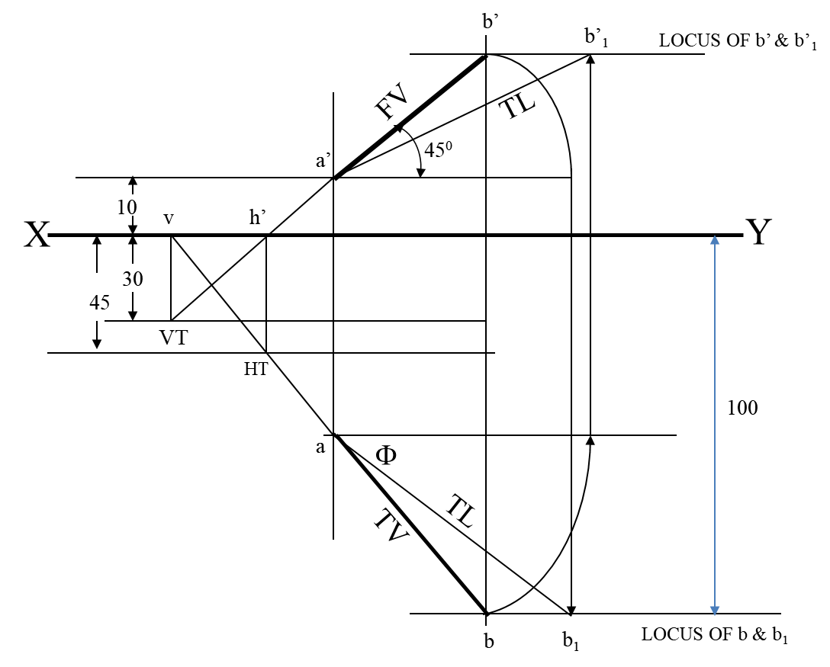

**SOLUTION STEPS:-**

1. Draw XY line, one projector and locate a’ 10 mm above XY.

2. Draw locus 100 mm below XY for points b & b1

3. Draw loci for VT and HT, 30 mm & 45 mm below XY respectively.

4. Take 450 angle from a’ and extend that line backward

to locate h’ and VT. Locate v on XY above VT. Locate HT below h’ as shown.

5. Then join v – HT and extend to get top view end b.

6.Draw projector upward and locate b’. Make ab & a’b’ dark.

7. Now as usual rotating views find TL and it’s inclinations.